Dear Students,

I hope this message finds you well.

For **Monday’s class**, we will have a **hands-on session** focused on **installing and deploying VS Code** on **OSU’s HPC cluster**. We will follow the tutorial:  
[**How to Use VS Code on Perlmutter**](https://www.youtube.com/watch?v=KHxxq1XscBY&list=PL20S5EeApOSvJw3IUG5rbTkypYyuwopof&index=1&t=2470s) during the class.

Our TA, **Shouwei Gao** (*gaosho@oregonstate.edu*), will assist by hosting the session in the classroom.

**Before attending the class, please ensure you have your OSU HPC account:**➡ [Request COE HPC Access](https://it.engineering.oregonstate.edu/hpc/request-coe-hpc-access)

-Wenqian

Tutorial for using VS code on OSU’s HPC cluster:

1. Request HPC access

https://it.engineering.oregonstate.edu/hpc

1. Enable your HPC account in TEACH

https://teach.engr.oregonstate.edu/teach.php?type=want_auth

1. Connect to the COE HPC Cluster

ssh [username@submit.hpc.engr.oregonstate.edu](mailto:username@submit.hpc.engr.oregonstate.edu)

Note. Make sure to change the ‘username’ in the command to your own username, and it should be the prefix of your school email.

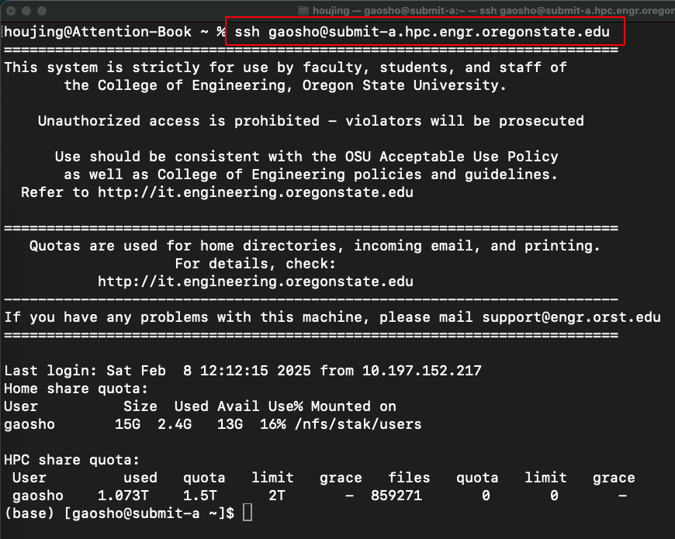

If you use a Windows computer, download MobaXterm first and launch the SSH client through MobaXterm.

1. Install Mobaxterm

[**https://mobaxterm.mobatek.net/download-home-edition.html**](https://mobaxterm.mobatek.net/download-home-edition.html)

**The portable edition is more easy to install.**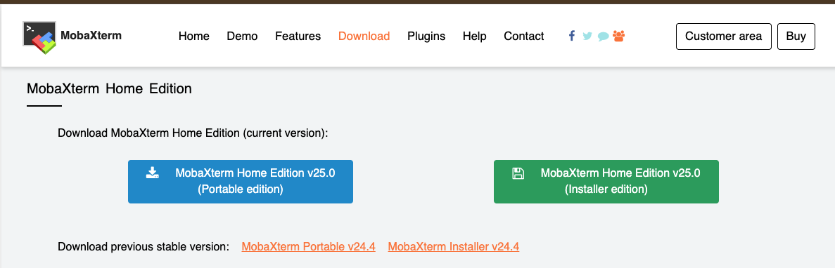

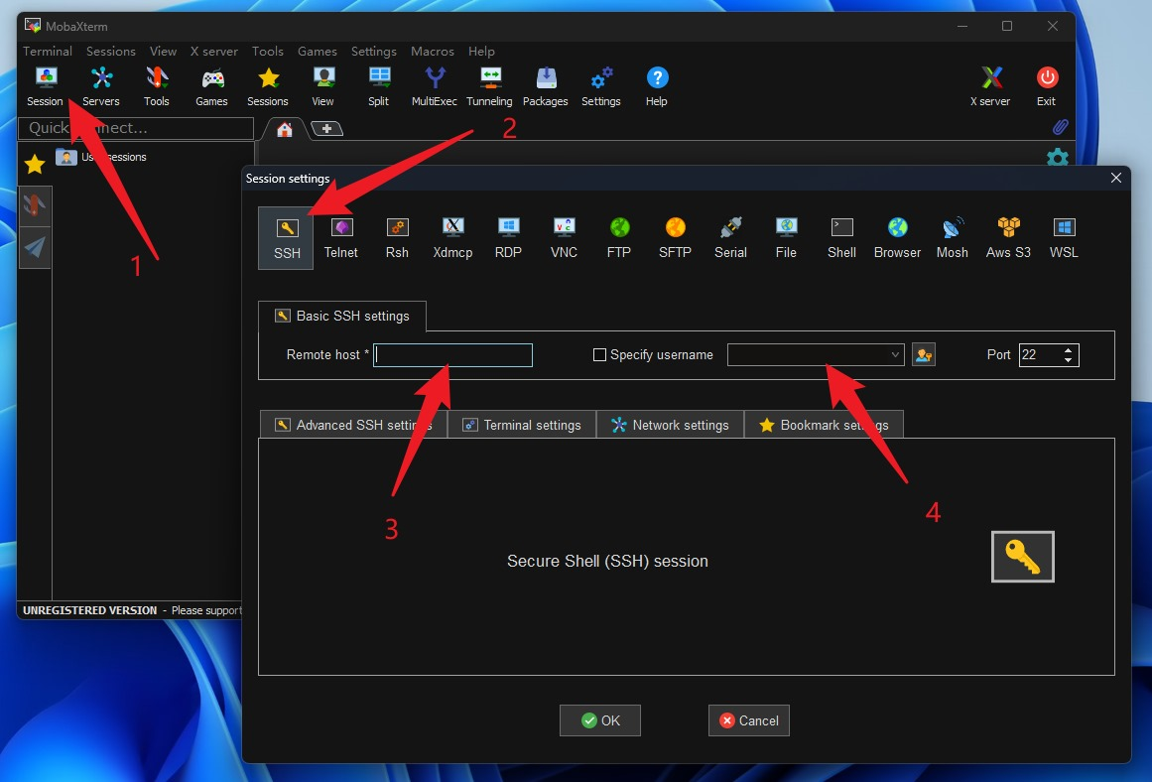

ssh [username@submit.hpc.engr.oregonstate.edu](mailto:username@submit.hpc.engr.oregonstate.edu)

Username: username

Remote host: [submit.hpc.engr.oregonstate.edu](mailto:username@submit.hpc.engr.oregonstate.edu)

1. Apply extra storage

Note: Everyone has a fixed 15 GB quota. Exceeding the quota can cause jobs on the cluster to fail, and other things to not work properly.

Researchers are given access to a global HPC scratch directory with a 1 TB quota that they can use to run their jobs from and to store data to. The global scratch directory is located in /nfs/hpc/share/username, where your userame is your ONID, or OSU Network ID.

Run in terminal:

ln -s /nfs/hpc/share/username hpc-share

Note: put everything there: cd hpc-share

1. Install VS Code and extensions
2. Download and install from <https://code.visualstudio.com/>

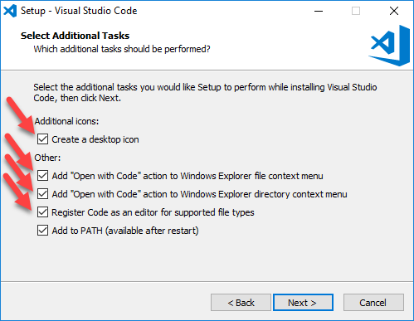

1. Install extensions
   1. Python

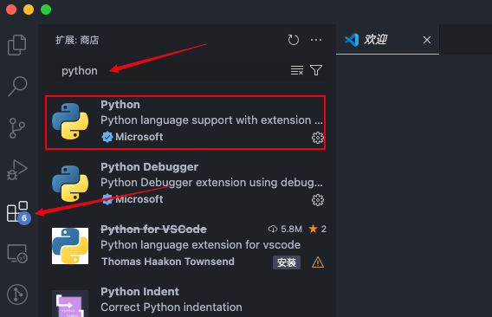

* 1. Remote SSH

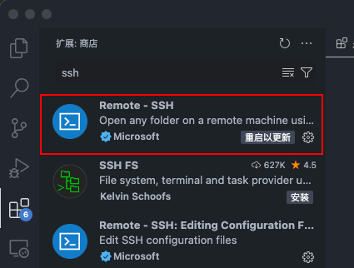

1. Connect cluster through VS Code

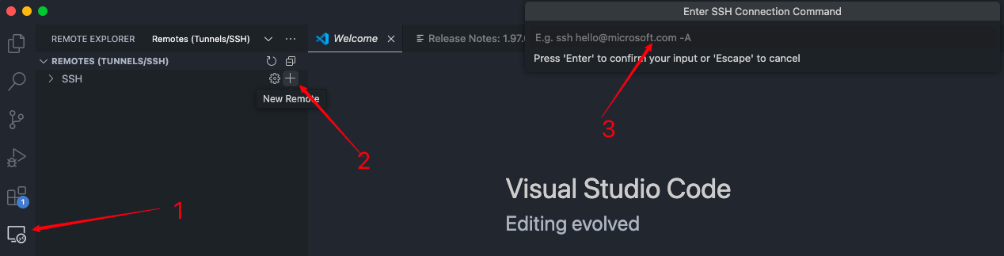

ssh [username@submit.hpc.engr.oregonstate.edu](mailto:username@submit.hpc.engr.oregonstate.edu)

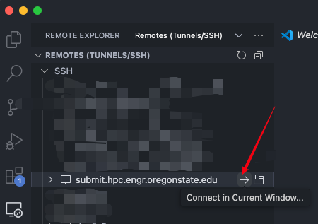

Check if you connected to the cluster

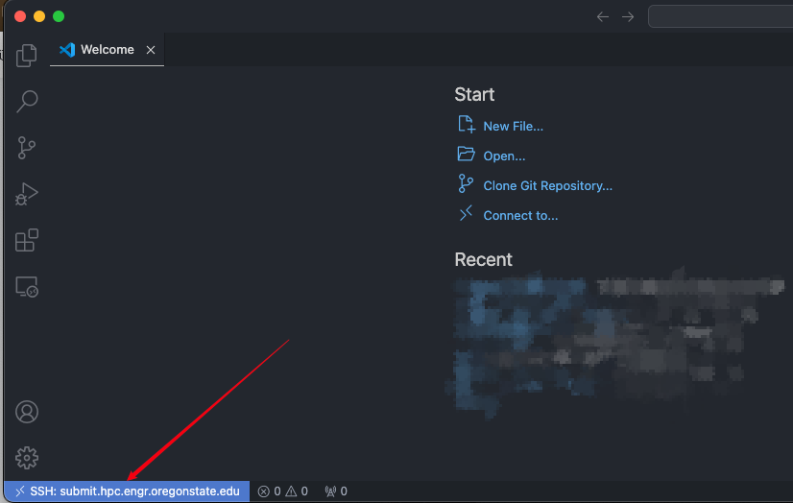

To open the terminal in VS Code: ctrl + J

Check the memory usage: du -ah --max-depth=1 | sort -hr

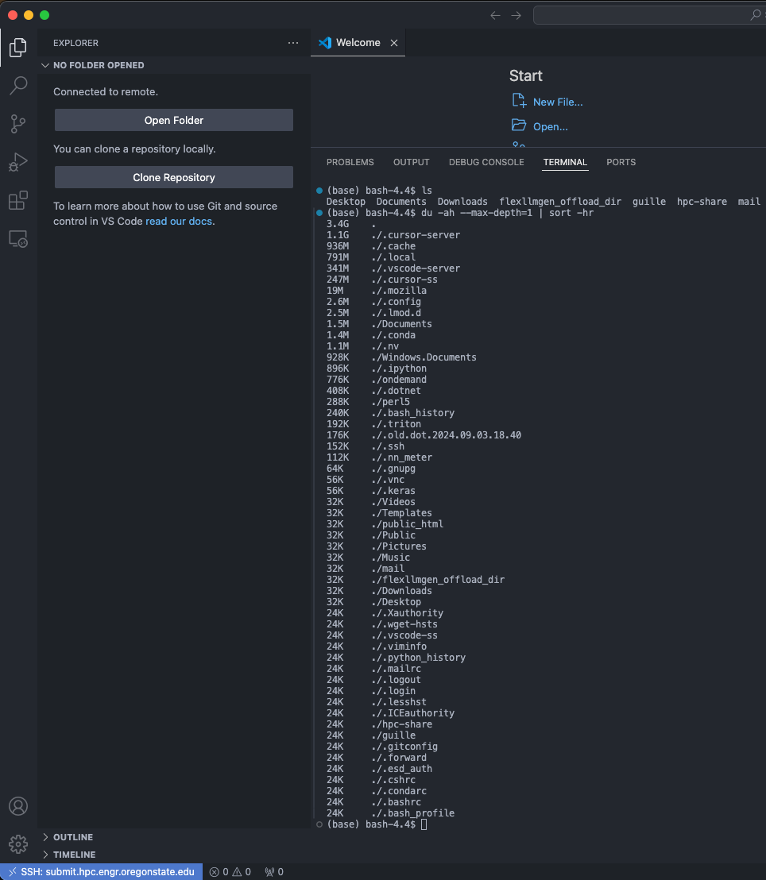

1. Run demo on cluster:

Clone demo code from github

Run in terminal:

git clone https://github.com/shwgao/CS-ECE-599-labs.git

Open

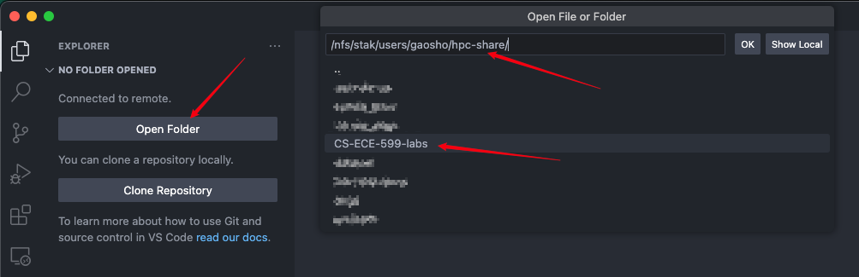

Run the demo code:

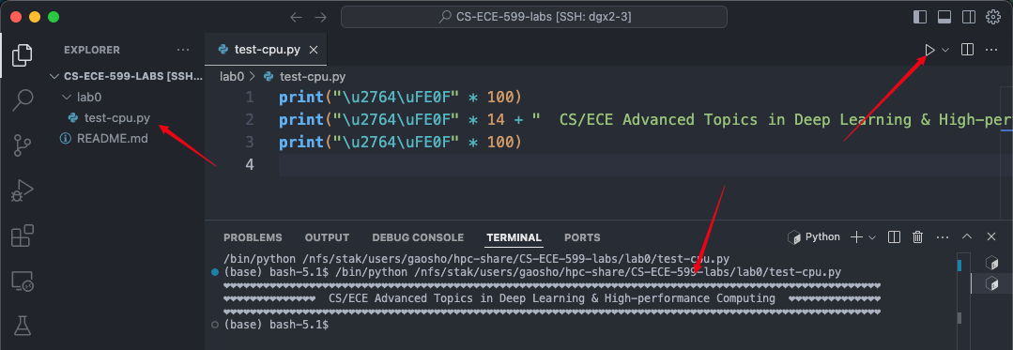

Note: you may install the Python extension again.

1. Request compute resources

Request one gpu on node gpu/dgx2 for one hour with RAM 64 GB

Run in command

1. **srun -A eecs --time=0-01:00:00 -p gpu,dgx2 --gres=gpu:1 --mem=64G --pty bash**
2. **nvidia-smi**
3. **hostname -f**

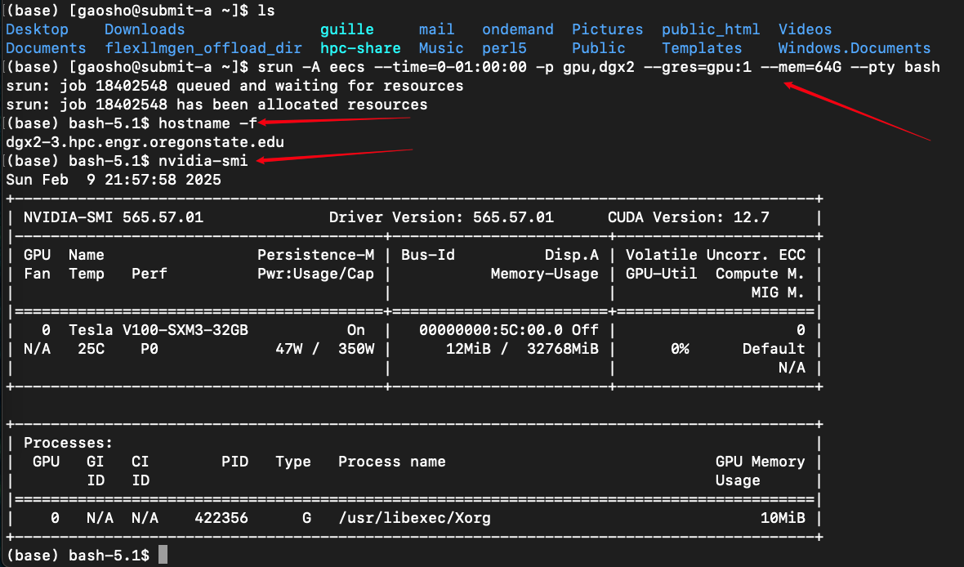

1. Access the GPU resource through VS Code



ssh username@{output of the command hostname -f}

